Name________________________________

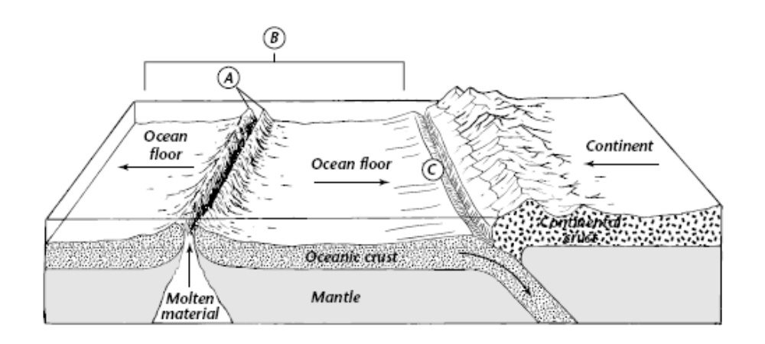
Sea Floor Spreading Worksheet

Use the figure above to answer the following questions.

1) What feature of the ocean floor is shown at A?

2) Describe the process shown occurring at B, and explain what results from this.

3) What happens to old oceanic crust as new molten material rises from the mantle?

4) The arrows on the figure show the ocean floor spreading from the ridge. What are three kinds of evidence scientists have found to support this idea?

5) What process is shown occurring at C, and why does it occur?

6) Where would you expect to find the oldest rock on the ocean floor?

Fill in the blank to complete each statement.
7) A device that scientists use to map the ocean floor is _______________________.

8) The feature on the ocean floor at C is called a(n) __________________________.

9) The process that continually adds new material to the ocean floor is called _______________________.

10) The process by which the ocean floor sinks into the mantle is called _______________________.

11) The chain of mountains that extends into all of Earth’s oceans is the ___________________________.

Modeling Sea-Floor Spreading Lab Questions

Answer the following questions using your model of sea-floor spreading.

1) What feature of the ocean floor does the center slit represent?

2) What prominent feature of the ocean floor is missing from the model at this point?

3) What do the side slits represent?

4) What does the space under the paper represent?

5) How does the ocean floor as shown by the part of a strip close to the center slit differ from the ocean floor as shown by the part near a side slit?

6) What do the stripes represent?

7) Why is it important that your model have an identical pattern of strips on both sides of the center slit?

8) How do the differences in density and temperature provide some of the force need to cause sea-floor spreading and subduction?



